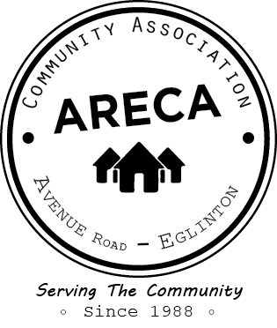
ARECA MEMBERSHIP 2019
Please print
Name: ________________________________________________________________________
Address: ______________________________________________________________________
Postal Code: ____________________________________
Email Address: ________________________________ @ _______________________________
Telephone: ____________________________
Yes, I would like to be on the E-Mail List

 | Household: | $20.00
 | Senior: | $10.00
 | Donation: | $ ________
 | Total: | $ ________
 | Method of Payment |  |  | Cheque |  | Cash

Please return this form with payment to:
ARECA, c/o 23 Elwood Blvd., Toronto, ON M4R 1B8

