 | 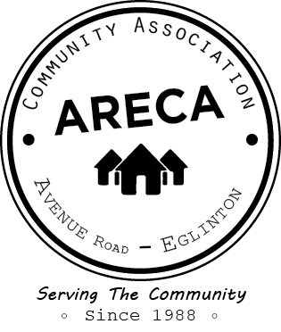
 | ARECA MEMBERSHIP 2022
 | Please print:
 | Name: _______________________________________________ |  | EMAIL LIST
 | Address: _____________________________________________ |  | Yes, add me to the list.
 | Postal Code: ___________________________________________
 | E-Mail Address: ___________________________________@ _____________________________________
 | Telephone: ____________________________________________
 | Household: $20.00
 | Senior: $10.00
 | Donation $ ________
 | Total: $ ______________
 | Method of Payment: Cheque Cash

Please return this form with payment to:
ARECA, c/o 23 Elwood Blvd., Toronto, ON M4R 1B8

